Homework 5

Structures & Union & Enum

**Example 1 C Program to Store Information(name, roll and marks) of a Student Using Structure**

In this program, a structure(student) is created which contains name, roll and marks as its data member. Then, a structure variable(s) is created. Then, data (name, roll and marks) is taken from user and stored in data members of structure variable s. Finally, the data entered by user is displayed.

**#include** <stdio.h>

**#include** <stdalign.h>

**struct** **Student**{

**double** marks;

**char** name[37];

**int** roll_number;

}s1;

**int** **main**()

{

**printf**("Enter information of students:\n");

**printf**("Enter name: ");

**fflush**(stdout);

**gets**(s1.name);

**printf**("Enter roll number: ");

**fflush**(stdout);

**scanf**("%d",&s1.roll_number);

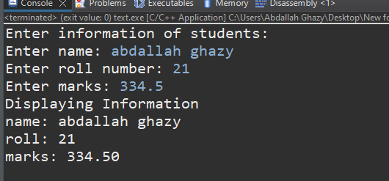

**printf**("Enter marks: ");

**fflush**(stdout);

**scanf**("%lf",&s1.marks);

**printf**("\nDisplaying Information\n");

**printf**("name: %s\n",s1.name);

**printf**("roll: %d\n",s1.roll_number);

**printf**("marks: %0.2f\n",s1.marks);

**return** 0;

}

**Example 2 C Program to Add Two Distances (in inch-feet) System Using Structures**

**#include** <stdio.h>

**struct** **Distance** {

**int** feet;

**float** inch;

} d1, d2, result;

**int** **main**() {

**printf**("Enter 1st distance\n");

**printf**("Enter feet: ");

**fflush**(stdout);

**scanf**("%d", &d1.feet);

**printf**("Enter inch: ");

**fflush**(stdout);

**scanf**("%f", &d1.inch);

**printf**("\nEnter 2nd distance\n");

**printf**("Enter feet: ");

**fflush**(stdout);

**scanf**("%d", &d2.feet);

**printf**("Enter inch: ");

**fflush**(stdout);

**scanf**("%f", &d2.inch);

result.feet = d1.feet + d2.feet;

result.inch = d1.inch + d2.inch;

**while** (result.inch >= 12.0) {

result.inch = result.inch - 12.0;

++result.feet;

}

**printf**("\nSum of distances = %d\'-%.1f\"", result.feet, result.inch);

**return** 0;

}

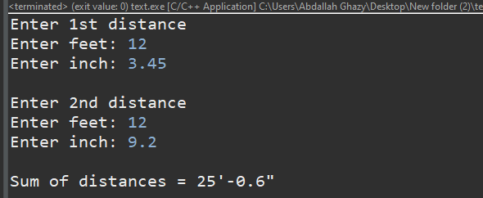

**Example 3 C Program to Add Two Complex Numbers by Passing Structure to a Function**

**#include** <stdio.h>

**struct** **ComplexNumbers** {

**float** real;

**float** img;

};

**struct** **ComplexNumbers** **SumComplexNumbers**(**struct** **ComplexNumbers** c1, **struct** **ComplexNumbers** c2);

**int** **main**() {

**struct** **ComplexNumbers** c1, c2, c_r;

**printf**("For 1st complex number\n");

**printf**("Enter real and imaginary respectively: ");

**fflush**(stdout);

**scanf**("%f + %f i", &c1.real, &c1.img);

**printf**("For 2st complex number\n");

**printf**("Enter real and imaginary respectively: ");

**fflush**(stdout);

**scanf**("%f + %f i", &c2.real, &c2.img);

c_r = **SumComplexNumbers**(c1, c2);

**printf**("\nSum Complex Numbers = %0.2f + %0.2f i", c_r.real,c_r.img);

**return** 0;

}

**struct** **ComplexNumbers** **SumComplexNumbers**(**struct** **ComplexNumbers** c1,**struct** **ComplexNumbers** c2) {

**struct** **ComplexNumbers** r;

r.real = c1.real + c2.real;

r.img = c1.img + c2.img;

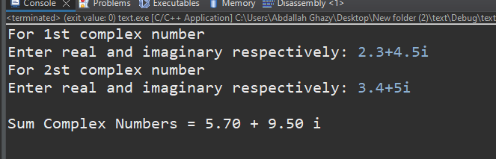 **return** r;

}

**Example 4 C Program to Store Information of Students Using Structure**

In this program, a structure(student) is created which contains name, roll and marks as its data member. Then, an array of structure of 10 elements is created. Then, data(name, roll and marks) for 10 elements is asked to user and stored in array of structure. Finally, the data entered by user is displayed.

**#include** <stdio.h>

**struct** **Student** {

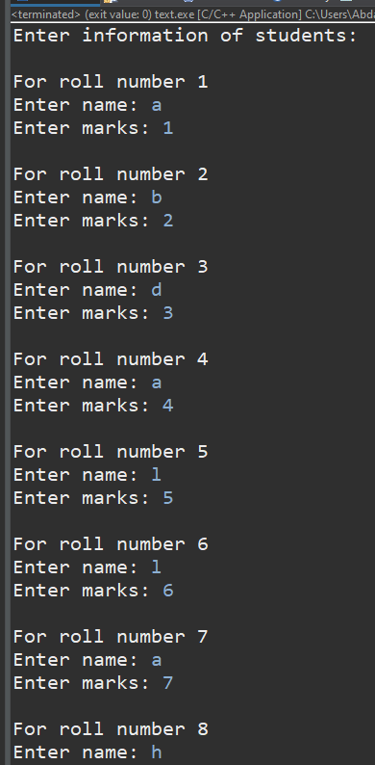 **double** marks;

**char** name[37];

**int** roll_number;

};

**int** **main**() {

**struct** **Student** Students[3];

**printf**("Enter information of students:\n");

**for**(**int** i = 0 ; i < 3 ; i++) {

**printf**("\nFor roll number %d\n", i);

Students[i].roll_number = i+1;

**printf**("Enter name: ");

**fflush**(stdout);

**fgets**(Students[i].name, **sizeof**(Students[i].name), stdin);

Students[i].name[**strcspn**(Students[i].name, "\n")] = 0;

**printf**("Enter marks: ");

**fflush**(stdout);

**scanf**("%lf", &Students[i].marks);

**getchar**();

}

**printf**("\nDisplaying Information\n");

**for**(**int** i = 0 ; i < 3 ; i++) {

**printf**("Information for roll number %d : \n", Students[i].roll_number);

**printf**("Name: %s\n", Students[i].name);

**printf**("Marks: %.2f\n", Students[i].marks);

}

**return** 0;

}

**Example 4 write the output of this program**

